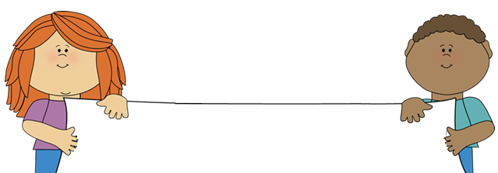

**Classroom News**

Susan Carroll – [scarrollpc@olatheschools.org](mailto:scarrollpc@olatheschools.org) Class Website - scarrollpc.weebly.com

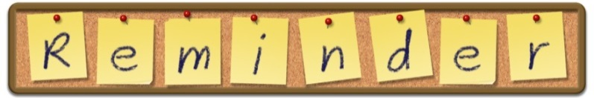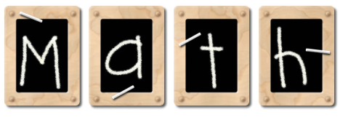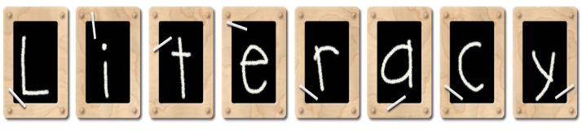

WE’RE

ALL

STARS

Monday – Music/Pe Thursday – Art

Tuesday – Computer Friday – Music/

Wednesday – PE/Library Library

This week we will be reading Peter Rabbit, From Seed to Plant and XXX. We are germinating beans before planting and planting grass in Mr. Harry Cup this week. We are also discussing parts of a plant and germination. We’ll find out who has a “green thumb!”

scarrollpc.weebly.com

**©**

**April 9th – Fourth grade musical**

**April 11th – PC Pals**

**April 12th – NO SCHOOL**

***If you ever forget ANY information or just want to look at pictures depicting the school day - scarrollpc.weebly.com***

We begin Topic 12 this week. We will see how objects can be compared by length, height, capacity, and weight?