

**Classroom News**

Susan Carroll – [scarrollpc@olatheschools.org](mailto:scarrollpc@olatheschools.org) Class Website - scarrollpc.weebly.com

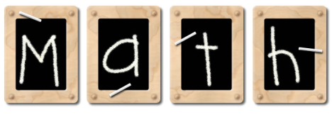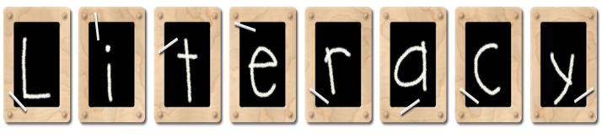la

WE’RE

ALL

STARS

Monday – Music/Library Thursday – PE/

Tuesday – Music/PE Library

Wednesday – Computer Friday - Art

We have finished our plant unit, but plants will still be coming home with instructions on how to continue to grow them. We will work with our Kindergarten Standard on what animals need to

survive and how they can change their environments to meet

their needs.

scarrollpc.weebly.com

**©**

**Thursday, May 2nd – Olathe West Naturalist Program**

**Friday, May 3rd – Leader In Me Assembly (Deputy Chief Daniels of the Olathe Police Department will be our speaker)**

***If you ever forget ANY information or just want to look at pictures depicting the school day - scarrollpc.weebly.com***

This week we will begin Topic 13, sorting, classifying, counting, and categorizing data. Same and different, sorting by one attribute, sorting the same set in different ways and sorting

by more than one

attribute.